Chapter 9
Exercises
9.3 (Using Composition Rather Than Inheritance)
Many programs written with inheritance could be written with composition instead, and vice versa. Rewrite class BasePlusCommissionEmployee (Fig. 9.11) of the CommissionEmployee–BasePlusCommissionEmployee hierarchy to use composition rather than inheritance.
Composition models a HAS-A relationship rather than an IS-A relationship. Instead of extending CommissionEmployee, class BasePlusCommissionEmployee contains a private reference to a CommissionEmployee object.
9.4 (Software Reuse)
Discuss the ways in which inheritance promotes software reuse, saves time during program development and helps prevent errors.
Inheritance promotes software development in three key ways:
- Software Reuse & Development Time: Subclasses inherit proven instance variables and methods from superclasses. Instead of re-writing redundant code, developers specialize existing classes, significantly saving development and testing time.
- Error Prevention: Superclasses are already thoroughly written, tested, and debugged. Reusing tested components reduces bugs in software systems.
- System Maintainability: Enhancements, updates, or bug fixes made to a superclass automatically propagate to all subclasses, eliminating code duplication and ensuring consistent behavior across the codebase.

9.5 (Student Inheritance Hierarchy)
Draw an inheritance hierarchy for students at a university similar to the hierarchy shown in Fig. 9.2.
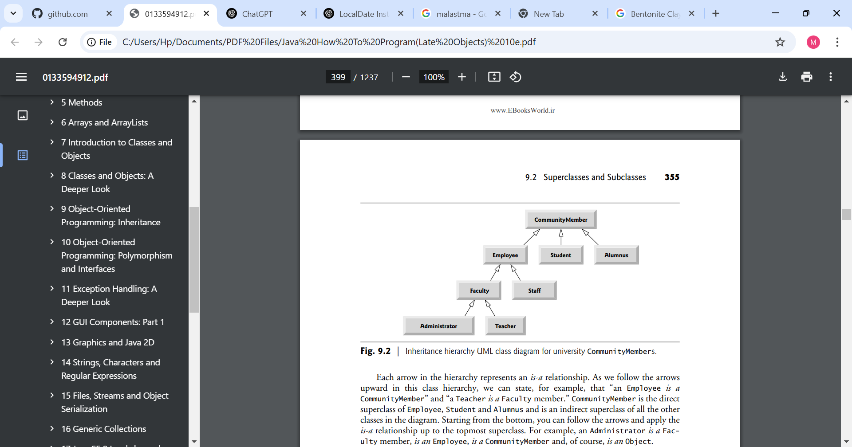Use Student as the superclass of the hierarchy, then extend Student with classes UndergraduateStudent and GraduateStudent. Continue to extend the hierarchy as deep (i.e., as many levels) as possible. For example, Freshman, Sophomore, Junior and Senior might extend UndergraduateStudent, and DoctoralStudent and MastersStudent might be subclasses of GraduateStudent. After drawing the hierarchy, discuss the relationships that exist between the classes. [Note: You do not need to write any code for this exercise.]
• Student: Root superclass containing general attributes applicable to all students (e.g., studentID, name, gpa).
• UndergraduateStudent & GraduateStudent: Direct subclasses extending Student via an IS-A relationship. UndergraduateStudent introduces attributes like academicMajor or creditHoursCompleted, while GraduateStudent adds attributes like academicAdvisor or undergraduateDegree.
• Freshman, Sophomore, Junior, Senior: Direct subclasses of UndergraduateStudent representing specific class standings.
• DoctoralStudent & MastersStudent: Direct subclasses of GraduateStudent representing specific graduate degree tracks, adding attributes such as thesisTopic or dissertationTitle

9.6 (Shape Inheritance Hierarchy)
The world of shapes is much richer than the shapes included in the inheritance hierarchy of Fig. 9.3.
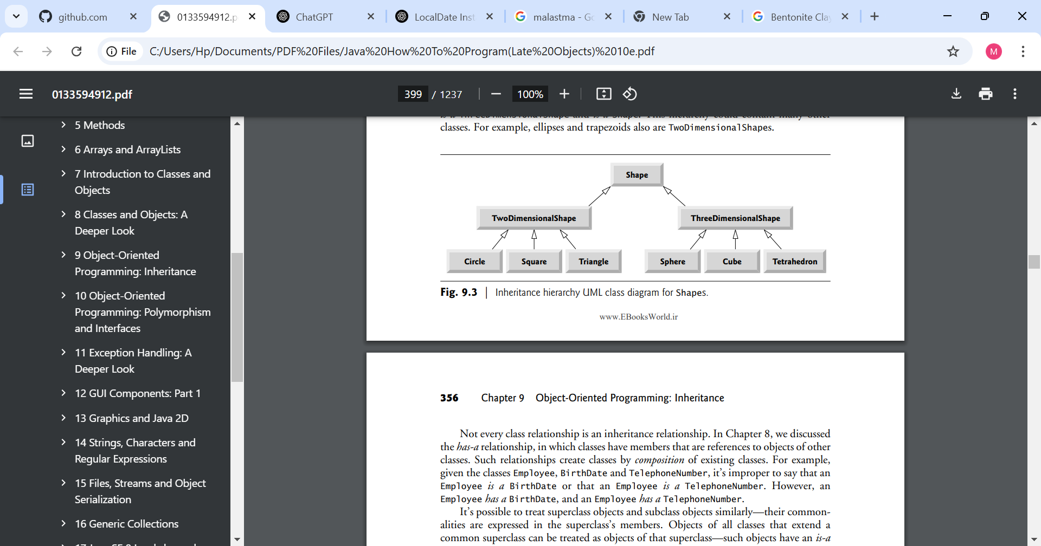
Write down all the shapes you can think of—both two-dimensional and three-dimensional—and form them into a more complete Shape hierarchy with as many levels as possible. Your hierarchy should have class Shape at the top. Classes TwoDimensionalShape and ThreeDimensionalShape should extend Shape. Add additional subclasses, such as Quadrilateral and Sphere, at their correct locations in the hierarchy as necessary.
• Shape: The top root superclass.
• TwoDimensionalShape & ThreeDimensionalShape: Direct subclasses extending Shape. TwoDimensionalShape defines standard behavior for flat shapes (such as getArea() and getPerimeter()), while ThreeDimensionalShape defines behavior for spatial figures (such as getArea() for surface area and getVolume()).
• Intermediate Classes: Classes like Polygon and Polyhedron further classify multi-sided geometry before branching into concrete shapes (Triangle, Quadrilateral, Cube, Tetrahedron

9.7 (protected vs. private)
Some programmers prefer not to use protected access, because they believe it breaks the encapsulation of the superclass. Discuss the relative merits of using protected access vs. using private access in superclasses.
• protected Access:
- Merits: Allows subclasses and package-friendly classes to access superclass members directly without calling accessor methods, simplifying subclass implementation.
- Demerits: Breaks encapsulation. Subclasses can alter private internal state directly without running through validation logic defined in setter methods. Additionally, if the superclass implementation changes, subclass code may break (tight coupling).
• private Access:
- Merits: Preserves encapsulation. Subclasses access instance variables strictly through public or protected getters and setters. This ensures validation rules are enforced and enables modifying internal superclass representations without affecting subclasses.
- Demerits: Requires calling methods rather than directly accessing instance variables.

9.8 (Quadrilateral Inheritance Hierarchy)
Write an inheritance hierarchy for classes Quadrilateral, Trapezoid, Parallelogram, Rectangle and Square. Use Quadrilateral as the superclass of the hierarchy. Create and use a Point class to represent the points in each shape. Make the hierarchy as deep (i.e., as many levels) as possible. Specify the instance variables and methods for each class. The private instance variables of Quadrilateral should be the x-y coordinate pairs for the four endpoints of the Quadrilateral. Write a program that instantiates objects of your classes and outputs each object’s area (except Quadrilateral).
9.9 (What Does Each Code Snippet Do?)
a) Assume that the following method call is located in an overridden earnings method in a subclass:
super.earnings()
b) Assume that the following line of code appears before a method declaration:
@Override
c) Assume that the following line of code appears as the first statement in a constructor’s body:
super(firstArgument, secondArgument);
• a) super.earnings()
- Invokes the overridden earnings method in the direct superclass from within a subclass method, executing the superclass logic before or alongside subclass processing.
• b) @Override
- A compiler annotation indicating that the method is intended to override a method declared in a superclass. If the signature does not match any superclass method exactly, the compiler generates an error.
• c) super(firstArgument, secondArgument);
- Calls a two-argument constructor of the superclass from within a subclass constructor. This must be the first statement in the subclass constructor body.

9.10 (Write a Line of Code)
Write a line of code that performs each of the following tasks:
a) Specify that class PieceWorker inherits from class Employee.
- Specify that class PieceWorker inherits from class Employee
public class PieceWorker extends Employee
b) Call superclass Employee’s toString method from subclass PieceWorker’s toString method.

b) Call superclass Employee's toString method from subclass PieceWorker's toString method:
Java
super.toString();
c) Call superclass Employee’s constructor from subclass PieceWorker’s constructor—assume that the superclass constructor receives three Strings representing the first name, last name and social security number.

9.11 (Using super in a Constructor’s Body)
super is used as the first statement in a subclass constructor to invoke the superclass constructor. Subclass objects contain all instance variables declared in their superclass, but private superclass fields cannot be directly accessed by the subclass. Calling super(...) passes initial parameters to the superclass so it can initialize its private instance variables and perform any validation logic.

9.12 (Using super in an Instance Method’s Body)
Explain why you would use super in the body of a subclass’s instance method.
When a subclass overrides a superclass method, the subclass method hides the superclass version. To access or re-use the superclass functionality within the subclass's overriding method, the subclass explicitly prefixes the call with super. (e.g., super.toString()).

9.13 (Calling get Methods in a Class’s Body)
In Figs. 9.10–9.11 methods earnings and toString each call various get methods within the same class. Explain the benefits of calling these get methods within the classes.
• Encapsulation & Maintenance: If internal representation of a variable changes, only getter methods need updates; methods like earnings() and toString() continue working seamlessly without modification.
• Subclass Compatibility: If a subclass overrides a getter method to modify how a value is calculated, methods calling that getter automatically receive the updated value.
• Consistency: Prevents bugs caused by accessing unvalidated raw variable data directly.

9.14 (Employee Hierarchy)
In this chapter, you studied an inheritance hierarchy in which class BasePlusCommissionEmployee inherited from class CommissionEmployee. However, not all types of employees are CommissionEmployees. In this exercise, you’ll create a more general Employee superclass that factors out the attributes and behaviors in class CommissionEmployee that are common to all Employees. The common attributes and behaviors for all Employees are firstName, lastName, socialSecurityNumber, getFirstName, getLastName, getSocialSecurityNumber and a portion of method toString. Create a new superclass Employee that contains these instance variables and methods and a constructor. Next, rewrite class CommissionEmployee from Section 9.4.5 as a subclass of Employee. Class CommissionEmployee should contain only the instance variables and methods that are not declared in superclass Employee. Class CommissionEmployee’s constructor should invoke class Employee’s constructor and CommissionEmployee’s toString method should invoke Employee’s toString method. Once you’ve completed these modifications, run the CommissionEmployeeTest and BasePlusCommissionEmployeeTest apps using these new classes to ensure that the apps still display the same results for a CommissionEmployee object and BasePlusCommissionEmployee object, respectively.
9.15 (Creating a New Subclass of Employee)
Other types of Employees might include SalariedEmployees who get paid a fixed weekly salary, PieceWorkers who get paid by the number of pieces they produce or HourlyEmployees who get paid an hourly wage with time-and-a-half—1.5 times the hourly wage—for hours worked over 40 hours.
Create class HourlyEmployee that inherits from class Employee (Exercise 9.14) and has instance variable hours (a double) that represents the hours worked, instance variable wage (a double) that represents the wages per hour, a constructor that takes as arguments a first name, a last name, a social security number, an hourly wage and the number of hours worked, set and get methods for manipulating the hours and wage, an earnings method to calculate an HourlyEmployee’s earnings based on the hours worked and a toString method that returns the HourlyEmployee’s String representation. Method setWage should ensure that wage is nonnegative, and setHours should ensure that the value of hours is between 0 and 168 (the total number of hours in a week). Use class HourlyEmployee in a test program that’s similar to the one in Fig. 9.5.

